Lab 4 – Convolution – 1-D

EE-3221/051 Digital Signal Processing

Dr. Marek Trawicki

By: Andrew Iliescu, Eduardo Diaz, & Than Win

23 January 2020

Introduction

The main objective of this lab consists of the use of MATLAB to apply an input signal to a system (impulse) response. This response will be analyzed using 1-D convolution in MATLAB.

Procedure

Materials:

* Laptop with MATLAB Software
* Earbuds or headphones

MATLAB Procedure:

* Load and listen to the original built-in discrete-time input signal x [n ] called *laughter*.
* Graph the *laughter* signal as the discrete-time input signal x [n ] and continuous-time input signal x (t ).
* determine the discrete-time output signal where the filter system (impulse) responses are *h[n] = {hLPF[n], hHPF[n], hBPF[n], hbsf[n]}.*
* Listen to the discrete time output signals y [n ]
* Graph the discrete-time input signal x n[ ], discrete-time system h [n ], and discrete-time output signal y [n ] for each filter system (impulse) response.

Results

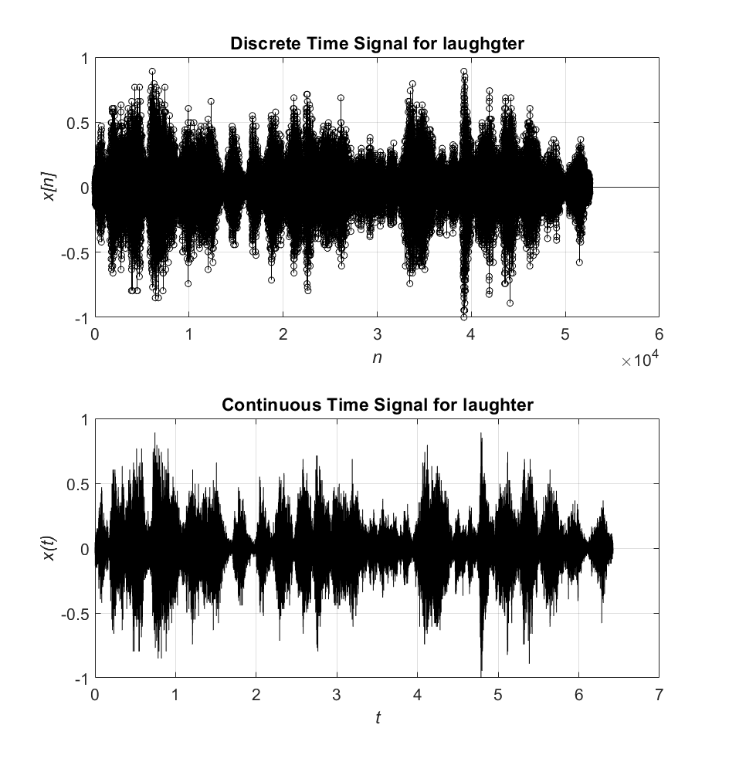

Figure 1: Discrete and Continuous Time signal for *Laughter.*

The original *laughter* signal is a combination of people laughing. The sound has a multitude of frequencies from high to low. This can be seen in Figure 1, where the magnitude of the signal has a wide range.

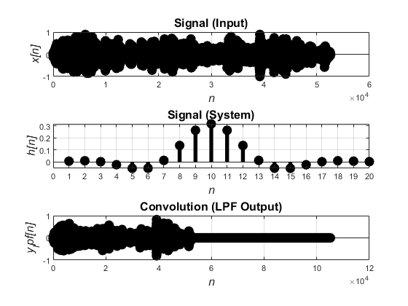

Figure 2: Output of the *laughter* signal through the FIR LPF system.

When the *laughter* signal is passed through a FIR LPF (Low Pass Filter) system, the range in frequency decreases and they tend to be lower in frequency. This can be heard from the new output signal, when the sound command is used. The sound itself sounds lower overall and the higher pitched laughter are gone.

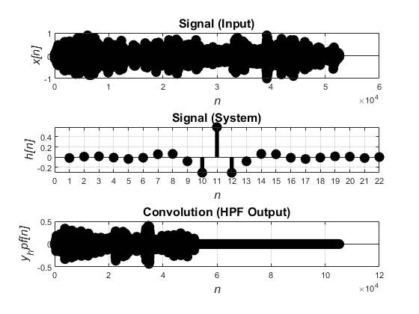

Figure 3: Output of the *laughter* signal through the FIR HPF system.

When the *laughter* signal is passed through a FIR HPF (High Pass Filter) system, the range in frequency decreases and they tend to be higher in frequency. This can be heard from the new output signal, when the sound command is used. The sound itself sounds higher overall and the lower pitched laughter are gone.

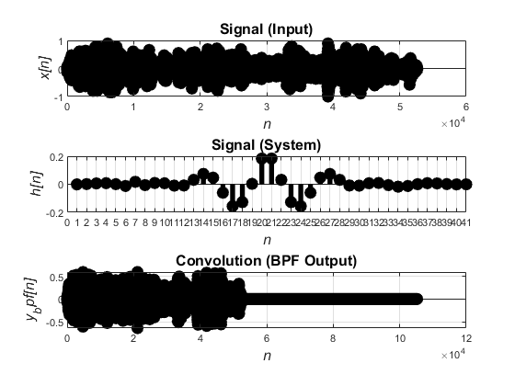

Figure 4: Output of the *laughter* signal through the FIR BPF system.

When the *laughter* signal is passed through a FIR BPF (Band Pass Filter) system, the range in frequency decreases and the frequencies that do stay tend to be in between the high and the low frequencies. This can be heard from the new output signal, when the sound command is used. The sound itself is blander and does not have any spikes of either high or low frequencies.

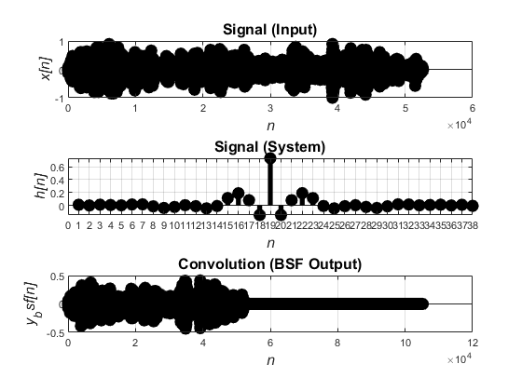

Figure 5: Output of the *laughter* signal through the FIR BSF system.

When the *laughter* signal is passed through a FIR BSF (Band Stop Filter) system, the signal seems untouched except that there is a specific frequency range missing. When listing to the signal alone it is hard to identify a difference but when directly comparing with the original the difference is clearer.

Conclusions

Overall, the *laughter* signal was modified and changed by passing it through different kinds of filters and analyzing them using 1-D convolution. As each different FIR system was used and the original signal was changed, the graphing of the system response showed how the original signal was changed specifically. These changes were specific and precise. These advance methods of modifying the input signal allows for specific changes to audio that simpler FIR system just can not achieve.

Questions & Answers

1. Given the FIR Differentiator (DIFF) (differentiation of frequency components) system with system (impulse) response



and laughter discrete-time input signal x n[ ], determine the discrete-time output signal y n[ ] . Listen to the discrete-time output signal y n[ ] using the sound command. Graph the discrete-time input signal x n[ ] (continuous-amplitude versus discrete-time), discrete-time system h n[ ] (continuous-amplitude versus discrete-time), and discrete-time output signal y n[ ] (continuous-amplitude versus discrete-time) using the stem command in 3 1× plot for the Differentiator (DIFF) system (impulse) response. Label all the appropriate quantities on the plots. Comment on the results.

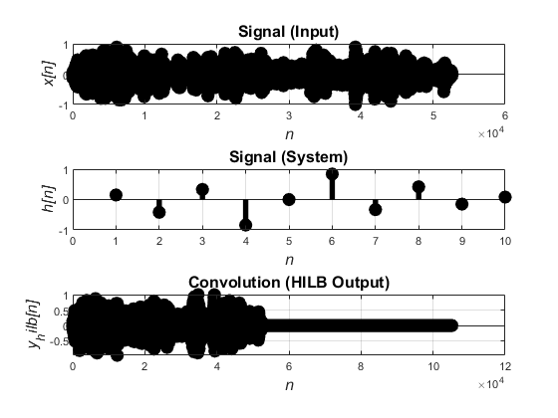

Figure 6: Output of the *laughter* signal through the FIR DIFF system.

Comment

2. Given the FIR Hilbert Transformer (HILB) system (phase shifter of frequency components) with system (impulse) response



and laughter discrete-time input signal x n[ ], determine the discrete-time output signal y n[ ] . Listen to the discrete-time output signal y n[ ] using the sound command. Graph the discrete-time input signal x n[ ] (continuous-amplitude versus discrete-time), discrete-time system h n[ ] (continuous-amplitude versus discrete-time), and discrete-time output signal y n[ ] (continuous-amplitude versus discrete-time) using the stem command in 3 1× plot for the Hilbert Transformer (HILB) system (impulse) response. Label all the appropriate quantities on the plots. Comment on the results.



Figure 7: Output of the *laughter* signal through the FIR HILB system.

Comment